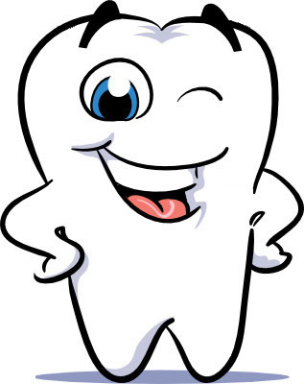

Welcome to Dr. McCuin’s Office

Patient Information

Name:_________________________________________
Address: ______________________________________
City: ____________________ State: _____ Zip _______
Home #:________________ Work#: _______________
Cell #: _________________ Date of birth: ___________
Referred by: ___________________________________
S.S.# _________________________________________
Marital Status: (please circle one)
single married divorced separated widowed
Employed by: __________________________________
Occupation: ___________________________________
Employment Address: ___________________________
City: ____________________ State: ____ Zip: ________

APPOINTMENTS: We require 24 hours notice if you cannot keep your scheduled appointment. A minimum charge will be made if you fail to notify us of cancellation. This fee covers only a portion of the overhead such as salaries, electric, heat etc., which still has to be paid whether you are present or not. Once you schedule an appointment remember that this time is reserved for you.

Signature: _______________________________

Date: _____________________

Dental History

Reason you came to see us today: ____________________________
Last dental exam: _________________
Any previous major dental treatment? ________________________
If yes when: _____________________________________________
Brief description: _________________________________________
What is the texture of your toothbrush? _______________________
How often do you brush? __________________________________

Do you have or have you had any of the following?
Please mark only the ones that apply to you.

___ Teeth sensitive to cold, hot, sweet or pressure
___ Bleeding gums (How long) _______
___ Oral habits, i.e. fingernail biting, cheek biting, thumb sucking
___ Swelling or lumps in the mouth
___ Frequent blisters on lips or mouth
___ Unusual sounds in ear while eating
___ Unfavorable dental experience
___ Complications from extraction
___ Food Impaction
___ Clenching or grinding ___ Pain around ear
___ Burning of the tongue ___ Bad taste in mouth
___ Mouth breathing ___ Periodontal Treatment
___ Orthodontic Treatment ___ Tobacco product use
___ Dental floss ___ Water jet device
___ Fluoride supplement ___ Bad breath

Do you like the way your smile looks? __________________

If no, what would you like to change about it? ____________
_________________________________________________

Medical History
Physician’s name: _________________________________
Date of last physical exam: __________________________

Have you ever been told you may need to be
pre-medicated with antibiotics prior to dental treatment due to heart problems and/or joint replacements? ____________
If yes, for which condition? _________________________

Are you allergic to any medications? __________________
________________________________________________

Do you currently have any of the following?
Please mark only the ones that apply to you

___ Allergies to anesthetics ___ Any heart ailments
___ Asthma ___ General allergies
___ Heart valve disease ___ Diabetes
___ High blood pressure ___ Stroke
___ Liver disease/hepatitis ___ Kidney disease
___ Neurological problems ___ Thyroid
___ Malignances (cancer) ___ Eye Disorders
___ Radiation or chemo ___ Tonsillitis
___ Anemia or blood problems ___ Tuberculosis
___ Psychiatric care ___ Ulcer or colitis
___ Rheumatic fever ___ Arthritis
___ Sinus problems ___ Pregnant
___ Excessive bleeding from cut or extraction?
___ Immune Disorder (AIDS, HIV, ARC ect)
___ Sleep Apnea

